The rules/logic for group project

Group 29 - Evan Ashby

Project - Card game called ‘Rules card’ where the user selects from a list of rules and plays against an AI opponent.

My main role in this project consisted of researching and making a list of rules for the game to use, writing the code for the logic of the game (code for each rule + base game) and combining all of the completed sections from group members to make the completed prototype. To find the rules that would be used for the game, I looked into some existing card games to find what rules are commonly used along with looking for some rules that are less used, but could still be used with the rest. Some card games that I found with a large number of rules that could be used are Big two and Rummy, as they have some fairly unique rules. After I had collected the research, I put it into a spreadsheet and listed each rule alongside the category of rule, how frequently the rule is used/what game it is from, and whether I thought the rule should be a higher priority. This spreadsheet is shown in the below images.

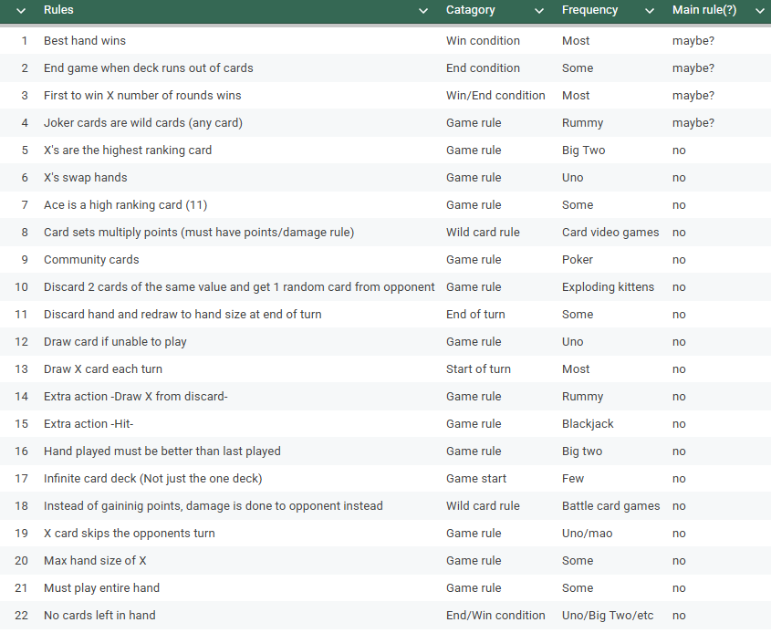
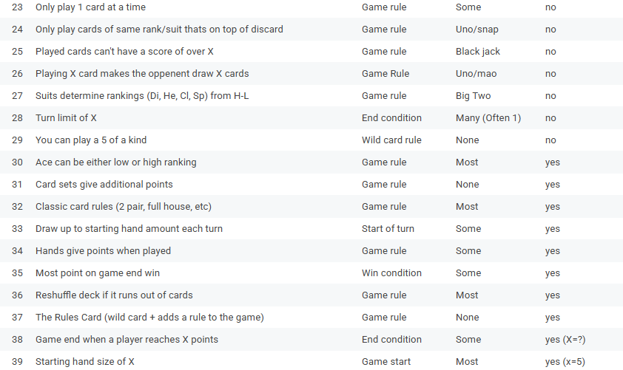

I also made the sprites used for the front and back of the cards used in the game. After collecting these rules, I began working on the basic code for the game. This included a simple deck with cards that one player had the ability to draw from and play cards from.

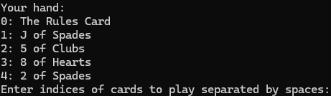
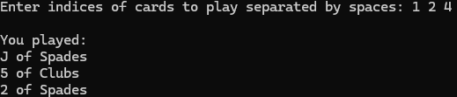

Afterwards, I implemented some of the rules into the game. These included a scoring system, Joker cards, drawing a set number of cards, and more. You are prompted at the start of the game to set whether you want the rules on or not. I also added the second player into the game, which is currently still user input.

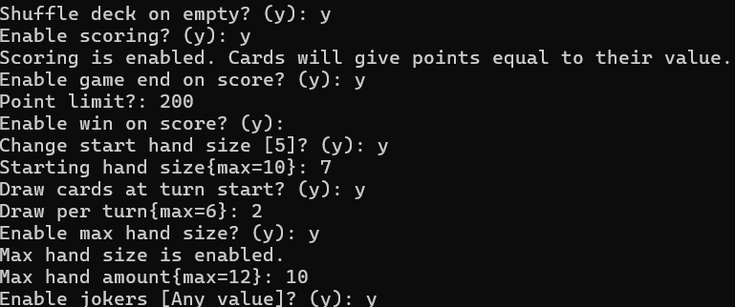
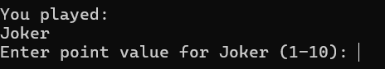
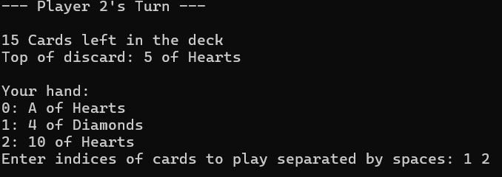

The last rule I implemented was the Rules Card, which, when played, enables a random rule which is disabled.

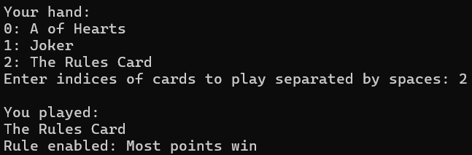

After doing that implementation of the base code in visual studio, I started to transfer it over into unity so that it can be combined with the rest of the main project. To start, I made the base implementation for cards, a discard pile and a play button.
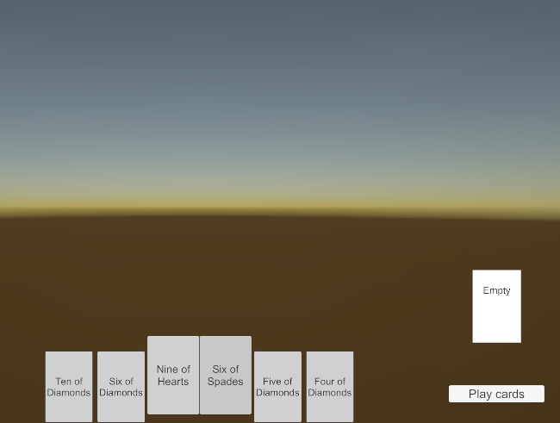
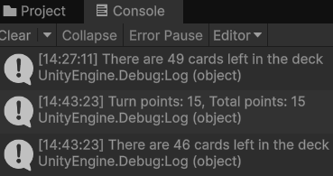

The rules were next to transfer over, with the main ones being the joker and rules card. Since the joker card needs input from the player, it creates a panel for the player to select from.
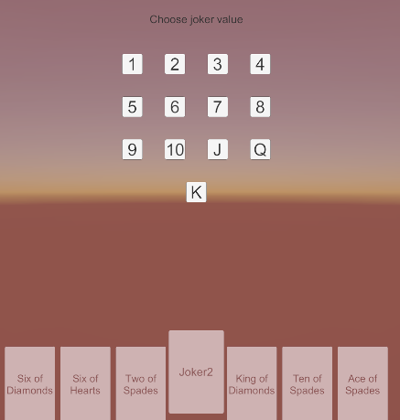

This version didn’t yet have an opponent to fight against as I had decided that it was best to implement that with the AI from the start instead of trying to put it into an existing system. So the next thing I did was mix this with the AI code and the assets/animations to prepare for the working prototype. I started this by implementing the AI opponent by calling the AI and sending it a prompt filled with its instructions and the rules. Its output is then read and turned into cards that it plays.

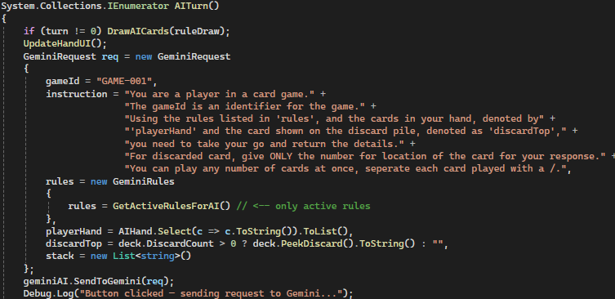

I then added the sprites onto the cards and moved the scene over to the animation scene, which included the deck object and card animations.

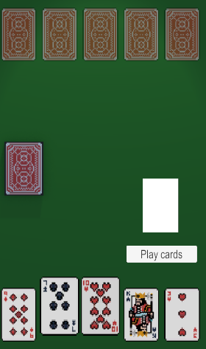

One of the last thing that I did was made sure that the different animations are called when they are required.

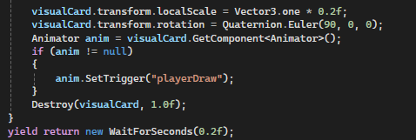

Finally, I implemented the main menu screen that was made, allowing it to transfer over to the game scene when the play button is pushed, and added buttons to the rule screen that allow the player to select the rules in game.

